**CHAPTER 4**

**FEASIBILITY**

**4.1 FEASIBILITY STUDY**

Before we started our work ,first of all we thoroughly studied the problem in the light of feasibility study in order to know whether the problem is feasible or not.

**4.2 ABSTRACT DEFINITION OF PROBLEM**

In the past it was very expensive to purchase a full barcode decoding system and maintain it, remember the prices of all equipments mostly used for this purpose are very high,

The maintainability cost is also very high, and a level of expertise is required for using those systems, It was a really a money consuming and was a big problem for the purchase department of an organization.

The small Organizations can not adopt the barcode system due to there high cost. Experienced employees are required for handling the system, and it consist of confusing hardware and software, which techniques cannot be understood easily, maintenance is big issue with these sophisticated devices.

A team of engineers is required to establish the system in a proposed organization, which will handle the defects in case of device is defected, and if the device become faulty some time it cannot be fixed again and a new one is required every time. most of the organization not prefer to use these device due to there several maintainability and handling issues.

**3.3 SOLUTION STRATEGIES**

The best solution to such problem is (Camera based barcode reader),which is used to track. The barcode is an computer system using a webcam. The automation bit ensures that the data from the barcode is captured quickly and accurately allowing a business to be more efficient. The Barcode has brought wide change in the field of technology.

It can be used for variety of purposes, such as attendance system in an office, it will cost lest and give rid from the conventional system.

We have to develop such an algorithm that can automatically detect the barcode from the image, and decode it,

If there is any sort of noise in the image containing barcode, our camera based barcode system gives accurate result, and omits the noice from the image.

Some of the noisy images are below.



In algorithm we used modular approach, so the each module can be combined to the new system.

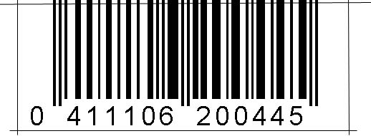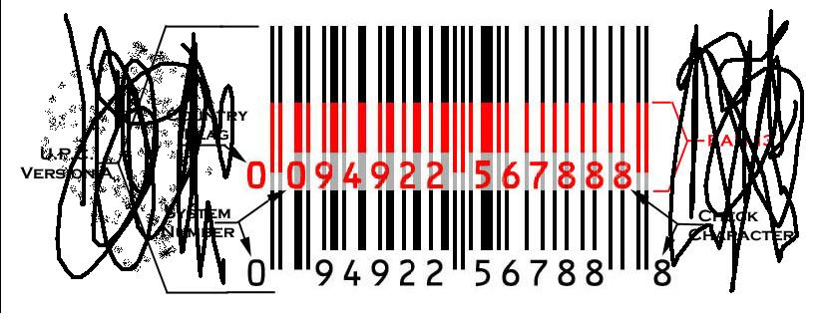 There we defined a function named that computes the intensity of while image, including the noise but do not include in result and omits it in computation by applying functions and constraints.





**3.4 BENEFIT**

Due to the modular approach, the algorithm can bend according to specific needs, like if we want it to support attendance system a database module can be attached to it, and it will function as attendance system, it can also be use for cargo tracking, on other hand if we purchase a full system it not supports all of the things at a time, for each and every purpose different type of scanners will be required, this software can easily replace the fixed scanners.

**3.4.1 TECHNICAL BENEFITS:**

Technically the new system would provide the following benefits.

● The new system is flexible to allow future enhancement.

● The new system is easily recoverable.

● The new system uses buttons control with understandable captions.

● With an error it creates an error message and informs the user that is going on.

● The software interface will be designed in such a way that they are easily to operate.

**3.4.2 OPERATIONAL BENEFITS:**

The proposed system provides user friendly interfaces which are easily to use and maintain. It doesn't involve any kind of overhead or mental stress and can be even used by any computer literal

**The developed system is beneficial for the following reasons.**

● Easy to use and operate.

● Provide fast response to end users and avoid unwanted timely delays.

● All the scanning process is safe and sound.

● All the process is done fair.

●Guarantees in counting security.

● Provides efficiency and reliability.

**3.5 Computer Application**

Investigated state-of-the-art small computer hardware and software to solve the model parameters, and develop generally applicable systems criteria that would pinpoint limitations, potential results, support requirements, and costs.

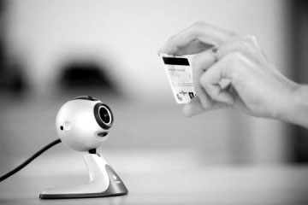 We believe the study is conclusive and does offer potential for a majority of uses. Small computers do offer ultimate system applications capable of man power saving, and saving the purchase budget.

**4.6 Conclusion**

Conclude that the study is conclusive and does offer potential for a majority of uses.